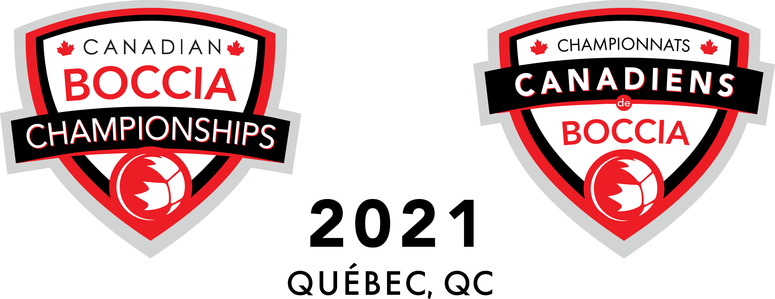
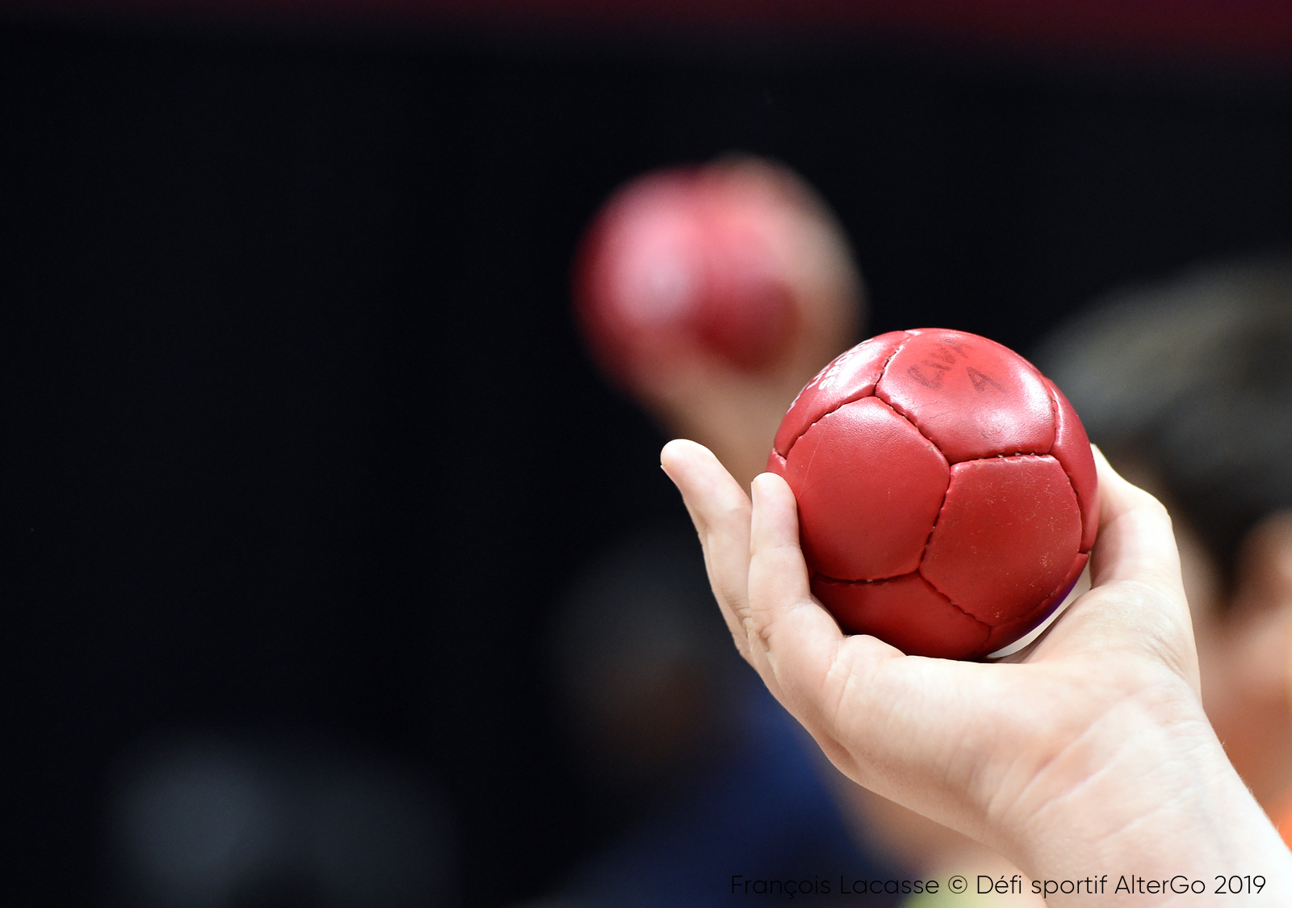2021 Canadian Championships COVID-19 Rules and Regulations
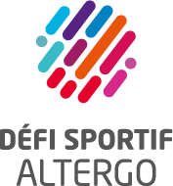
En collaboration avec
In collaboration with
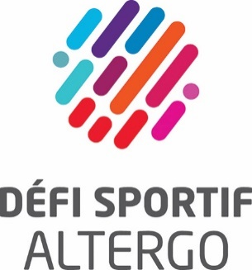
En collaboration avec
In collaboration with

The organizing committee of the Canadian Boccia Championships is dedicated to the health of all participants* and is committed to create a safe competition environment for all. To this end, the organizing committee has established these clear rules to reduce the risks associated with a COVID-19 outbreak, respecting health regulations of the Government of Quebec, Boccia Canada and the local venue operators.
Although the organizing committee will be the first to ensure compliance with these rules, participants themselves will play a key role in ensuring a safe competition by following these guidelines.
However, no guidelines can completely eradicate the risk of exposure to COVID-19 at a public event. It is the responsibility of each athlete, coach, official and volunteer to consider their personal risk tolerance and determine whether they are willing and able to participate in the event.
Finally, while there’s no strict hotel confinement for participants, the organizing committee invites you to be careful during activities outside the competition by respecting basic health instructions in effect in Quebec.

Proof of Vaccination
- All competition participants will be required to be adequately protected. The "Adequately protected" status means you received two doses of a Pfizer, Moderna, AstraZeneca, or Covishield COVID-19 vaccine OR one dose of these vaccines at least 21 days after contracting COVID-19 OR one dose of Janssen COVID-19 vaccine.

- Verification will be done at the hotel upon first arrival for delegations.

- Proof of vaccination and proof of identity will be checked to get the accreditation. Each participant must come and pick up their own accreditation individually.

- A second validation will be done for the first breakfast (hotel regulation).

- Verification at the competition site for volunteers

- Wearing the accreditation certifies that the proof of vaccination has been validated.

- A participant who can’t be vaccinated must show a medical exemption proof, provided by a physician or a nurse practitioner.
  - Exemption proof must include name and contact information of the physician or nurse practitioner and a precise statement for the medical reason, based on the exemption guidelines. French form can be found here.
  - He/she must produce a negative COVID-19 test taken no more than 72 hours before their arrival at the competition.
Mask wearing
- All competition participants will be required to wear a medical grade 2 mask for nose and mouth covering at all times, unless they are not able to do so. In this case, the participant must wear a protective visor.

- The mask may be removed during meals and snacks. Athletes may remove their masks while on the field of play. For team/pairs competition, as a 2 m physical distance can’t always be guaranteed, athletes must get approval from all other players before removing their mask while playing.

- Masks will be provided by the organizing committee for the duration of the event, both at the hotel and at the competition site.

- Prevention kits will also be given at delegations’ and officials’ arrival. It includes packages of disposable tissues, medical masks, alcohol based hand wipes and alcohol based hand sanitizer.

- Replace masks when they become damp.

Venue Access
- Each participant will have to complete a waiver before the beginning of the competition.
- Fill out a daily virtual COVID-19 attestation form every morning before getting to the venue to certify that the participant has no symptoms.

  - If he/she shows symptoms, the participant will not be allowed to access the site. The organizing committee will contact the public health department, who will determine the next steps. All other adequately vaccinated participants won’t have to be isolated for the moment.
- Disinfection of hands is mandatory.
- No spectators will be allowed on the competition venue.
- Participants can watch the competition only if they are in the designated zone, respecting physical distancing and zone capacity.

Basic health instructions
- Disinfection of the wheelchair and all equipment brought to the competition site is recommended regularly. Arm rests, joy stick, wheels, etc. can be wiped down with a disinfectant wipe or spray.
- Maintain a 2 m physical distance at all times.
- Regular handwashing or hand sanitizing.
- Always cough into a mask, sleeve or tissue.
- Throw away used tissues/disposable masks.
- Minimize items taken into the call room and field of play.
- Bring a refillable water bottle.
- Respect signage in any indoor space.
- Respect rooms capacity established according to physical distancing regulations.
- Avoid unnecessary physical contact with individuals from different households (i.e. handshakes, hugs, kisses)
- Avoid unnecessary crowding at the hotel and venue.

The organizing committee will ensure strict adherence to these measures in order to reduce the risk of transmission and outbreak. In accordance with the laws enforced in Quebec, a participant may be fined up to $6,000 if he or she does not respect the sanitary measures. This fine would be at the participant's expense; the organizing committee cannot be held responsible for it.
* Competition participants include but are not limited to athletes, performance partners, COVID assistants, coaches, officials and volunteers. COVID Assistants are defined as individuals the athlete requires to be at the competition in order to be able to participate (i.e. to provide personal care or push their wheelchair on court).

